www.ajlifesciences.com / ISSN: 2663-1040 AJ Life Sci. 2022, 5 (1): 7-15
Research Article

Abasyn Journal of Life Sciences

Open Access
DOI: 10.34091/AJLS.5.1.1

Repellent potential of medicinal oils against Tribolium castaneum (Herbst) under laboratory conditions

Tanzeela-ul-Zahra Khaskheli¹, Lubna Bashir Rajput¹, Shafique Ahmed Memon², Khalid Hussain Dhiloo¹, Nafeesa Zahra Khaskheli¹, Qurat Ul Ain Bhatti³, Arfan Ahmed Gilal^{1*}

¹Department of Entomology, Faculty of Crop Protection, Sindh Agriculture University, Tandojam, Sindh, Pakistan.
²Uthal University of Agriculture and Marine Science, Lasbella, Pakistan.
³Department of Agronomy, Faculty of Crop Production, Sindh Agriculture University, Tandojam, Sindh, Pakistan.

Abstract
Laboratory experiments were conducted to determine repellency of five local medicinal oils i.e., neem Azadirachta indica A. Juss., castor Ricinus communis L., rapeseed Brassica napus L., lettuce Lactuca sativa L. and chamomile Anthemis cotula L. against Tribolium castaneum Herbst, each applied at 0.1, 0.5- and 1.0-ml doses. A glass cylinder divided into A, B and C sections with one end close was used. Fifty grams of wheat flour was placed at A and C ends. Twenty freshly emerged T. castaneum was released at the center of cylinder (B). The data was recorded after one-, two- and three-days to count number of T. castaneum at A and C for calculating percentage repellency. All the oils showed repellent potential against T. castaneum as their repellency increased with dose and time exposure. After three days, 100% repellency of T. castaneum was recorded in 0.5- and 1.0-ml doses of neem oil, followed by 6.67±3.33% repellency at 0.1 ml neem oil. After three days, the maximum repellency of T. castaneum in rapeseed, castor, chamomile, and lettuce was 86.67±7.26, 76.67±6.01, 76.67±4.41, and 75.00±7.64%, respectively, all recorded at 1.0 ml dose. Overall, neem oil exhibited significantly more repellency of T. castaneum, whereas castor, lettuce, rapeseed and chamomile were found non-significant with each other. Among doses, although highest repellency was recorded at 1.0 ml dose, but not significantly different from 0.5 ml dose of the individual oil. Therefore, 0.5 ml should be applied per 50 grams of wheat flour to get effective repellency of T. castaneum.

Keywords: Beetle, Flour, Medicinal oils, Repellency

Key words:

Article Info:
Received:
February 18, 2021
Received Revised:
December 17, 2021
Accepted:
December 21, 2021
Available online:
December 31, 2021

*Corresponding Author: aagilal@sa.edu.pk

- INTRODUCTION
The red flour beetle, Tribolium castaneum (Herbst) (Coleoptera, Tenebrionidae), is an important polyphagous insect pest of stored products characterized by its strong adaptability to diversified environments. It can damage a wide range of cereals, grains and grain products^{1,2}. It is not only feeding on stored products but also contaminates them with their body parts and feces. The abdominal defense glands of this insect can secrete benzoquinones, that produce a pungent odor in the infected commodities and strongly depreciate the quality of the foodstuffs^{3,4}. Alone, T. castaneum can cause 5-30% infestation in stored commodities, thus the timely management of this noxious pest is required⁵.
Currently, the management of noxious stored grain pests is mainly dependent upon the usage of synthetic chemicals. However, injudicious, and heavy use of the chemicals in warehouses and agro-ecosystems have led to develop resistance among many serious pests including T. castaneum⁶. Moreover, synthetic pesticides’ persistency in the environment has created many harmful impacts on humans and other vertebrates along with disturbance to ecosystem, and depletion of ozone layer^{7,8}.
During last century, microbial- and plant-based pesticides have been exploited on large scale against many harmful pests because of most of them possessed a rich quantity of secondary metabolites that are capable of to elicit insecticidal and repellent properties against many pests including insects^{9,10}. A wide variety of chemicals such as terpenoids, steroids, alkaloids, and phenolics are produced by the plants for their defense and same are reported to have important medicinal and insecticidal activities^{11,12,13,}. Thus, essential oil derived from plants are considered as one of the key sources in the preparation of bio-pesticides^{14,15,16}, and can considered as a potential alternate of the synthetic pesticides due to their less persistency, reduced impact of the environment and non-target organisms including humans and their domesticated animals¹⁷.
Therefore, essential oils derived from many indigenous plants from various countries of the world have been tested and proved their effectiveness against insect pests, particularly T. castaneum has been reported to be sensitive against many of these essential oils and their active components^{18,19,20}. Mostly these botanical pesticides or their essential oils growth and metabolic activities of the targeted insects through enzymatic activities and physiological processes²¹. Accordingly, a quest for the development of botanical pesticides as alternative to synthetic insecticides has increased mainly because these botanicals are safe to humans and environmental¹⁴. Moreover, the understanding the biochemical properties of botanical pesticides against insect pests may provide safe management tools for keeping pest populations below threshold levels. Accordingly, this research was conducted to determine the repellent effect of various medicinal plant oils against T. castaneum.
2. MATERIALS AND METHODS
2.1 Studied Area
Study was carried out at Stored Grain Research Laboratory, Department of Entomology, Sindh Agriculture University, Tandojam during 2019-2020.
2.2 Samples collection
The culture of T. castaneum was collected from the laboratory-maintained stock at Stored Grain Research Laboratory, Department of Entomology. Further rearing of insects was carried out in the laboratory in fresh wheat flour in glass jars. Afterwards, freshly emerged adults obtained from this culture were used in the repellent bioassay.
2.3 Medicinal oils
Five medicinal oils i.e., Neem, Azadirachta indica A. Juss., Castor, Ricinus communis L., Rapeseed, Brassica napus L., Lettuce, Lactuca sativa L., Chamomile or Mayweed, Anthemis cotula L. were used in the study. Selection of medicinal oils was based on their medicinal potential, local availability and low cost. All the oils were obtained from the local market. Three doses i.e., 0.1 ml, 0.5 ml and 1.0 ml of each oil were used in the study.
2.4 Experimental setup, data collection and analysis
The experimental setup was adopted from Park et al.²² and and Lee et al.²³ with slight modifications. A long cylinder, sealed from one end was divided into three areas (A, B, C), whereas the other end was sealed with thick cloth for ventilation and retention of T. castaneum inside the cylinder during the entire duration of experiment. The repellent efficacy of the essential oils and plant extracts against insects was evaluated according to the method used by Jo et al.²⁴. Each dose of the respective oil was applied on the filter paper that was allowed to dry completely before placing them inside the cylinder. A control filter paper without oil was also used. The treated filter paper was introduced between A and B, whereas the control filter paper was placed between B and C (Fig. 1). Ten pairs of freshly emerged T. castaneum adults were released in the middle of B with help of a camel brush. The experiment was conducted under the temperature regime of 30±5°C and 60±5% relative humidity.
The data on repellence of medicinal oils against T. castaneum was recorded on daily basis for three days. At each data collections, wheat flour from portion C was carefully transferred into a glass tray to count the number of T. castaneum with the help of a camel brush. After data collection, the flour along with T. castaneum was gently placed back at the same place at C. Similar trend was followed at second and third day of the observations.
The repellent efficacy of medicinal oils was calculated using the following equation:
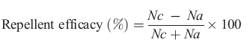
Where, Nc is the number of insects in C, and Na is the number of insects in A.
The experiment was arranged in a completely randomized design, where each treatment oil was replicated three times. Separate glass cylinders were used for the individual medicinal oil, where cylinders were thoroughly cleaned with tissue paper after performing each replication. The Analysis of Variance was used to analysis the data, whereas the means with significant differences were separated using the Least Square Difference (LSD) at 5% probability. All the analyses were performed through STATISTIX 8.1 computer software.
3. RESULTS AND DISCUSSIONS
All the medicinal oils used showed the repellent potential against T. castaneum. According to results, after one day, the highest repellency percentage of T. castaneum at 0.1 ml dose was recorded in neem oil (53.33 ±6.67 %), followed by castor oil (36.66±12.02%), whereas the minimum repellency was observed in lettuce oil (23.33±8.82%). A gradual rise was observed in the efficiency of medicinal oils to elicit repellent effect against T. castaneum with increasing their doses as the highest and lowest percentage repellency at 0.5 ml dose was recorded in neem oil (58.33±7.26%), and chamomile oil (33.33±8.82%), respectively. Similar trend in results was recorded at 1.0 ml dose of the oils as neem oil showed the highest repellency (80.00±5.77%), followed by rapeseed oil (60.00±5.77%), whereas the lowest repellency was recorded in castor and lettuce oils (43.33±12.02%), followed by chamomile oil (53.33±7.26%) (Fig. 2). Overall, after one day, there was no significant difference recorded in various doses of medicinal oils for their repellent potential against T. castaneum (F = 0.41, P = 0.9087).

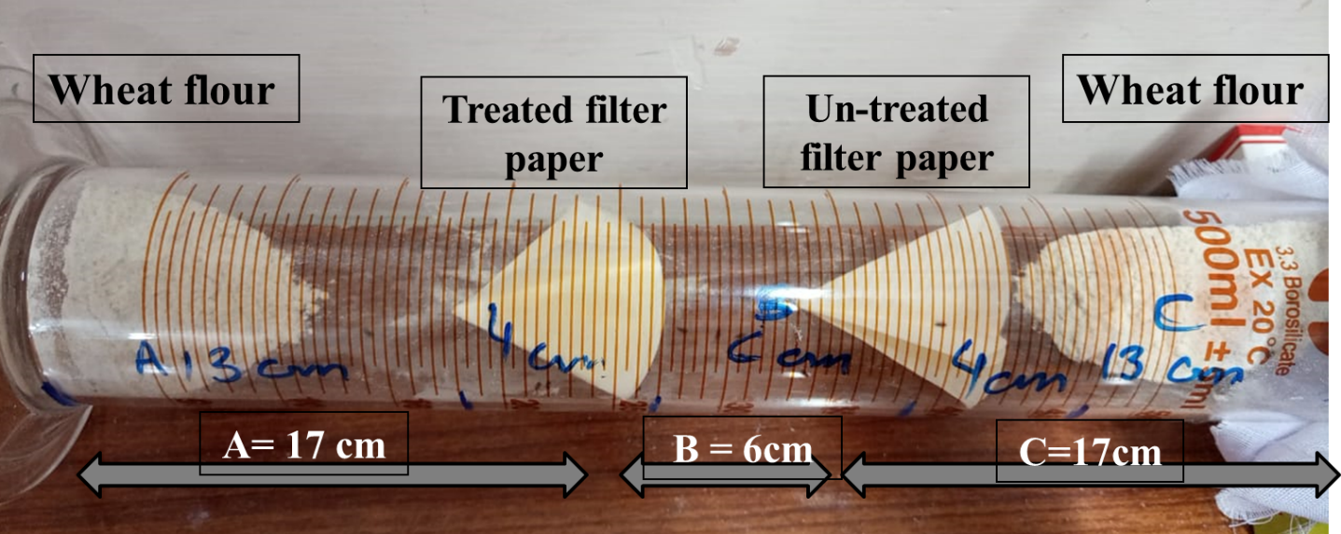
Fig. 1. Systematic diagram of cylinder trap for evaluating repellent efficacy of medicinal oils against Triobleum castaneum.

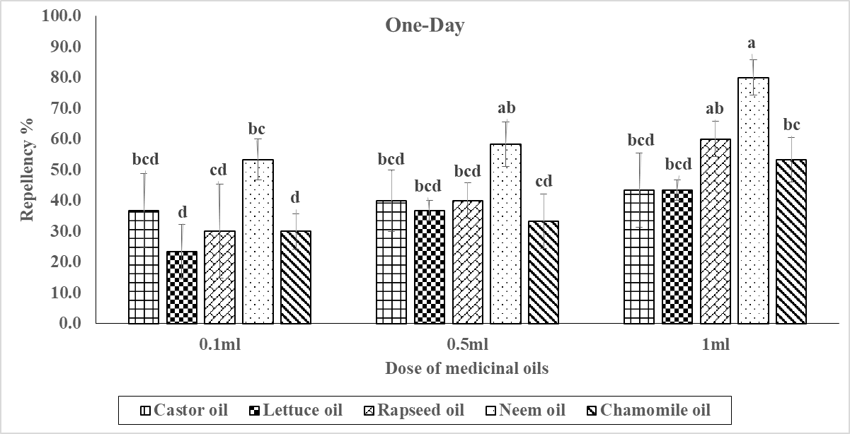
Fig. 2. Repellency percentage of different concentrations of medicinal oils against Tribolium castaneum after one day *Means followed by same letters are not significantly different (LSD = 24.54; P < 0.05)

Fig. 3 describes the results regarding the repellency percentage of T. castaneum due to the application of different doses i.e., 0.1, 0.5 and 1.0 ml of five medicinal oils after two-days. Like one-day, the combination effect of various doses of medicinal oils exhibited no significant difference (F = 0.70, P = 0.6883) in their repellency, however, a rise was recorded in the repellency of medicinal oils against T. castaneum. According to results, after two-days, the highest repellency at 0.1 ml dose was recorded in neem oil (78.33±1.67%), followed by castor (55.00±8.66%), whereas the lowest repellency of T. castaneum was recorded in lettuce (38.33±8.82%) oils. A steady rise was witnessed in the efficacy of medicinal oils in their repellent effect against T. castaneum at 0.5- and 1.0-ml doses. Accordingly, after two-days at 1.0 ml dose, neem oil repelled 96.67±5.77% T. castaneum, whereas the lowest repellency was recorded in chamomile oil (55.00±7.26%).
After three-days, a further repellency was recorded in different dozes of all medicinal oils as 100% repellency was recorded in 0.5- and 1.0-ml doses of neem oil, whereas 96.67±3.33% repellency was recorded at 0.1 ml dose of neem oil. Among remaining oils i.e., rapeseed, castor, chamomile and lettuce, the highest repellency recorded was 86.67±7.26, 76.67±6.01, 76.67±4.41, and 75.00±7.64%, respectively, all recorded at 1.0 ml dose (Fig. 4). Accordingly, like results of one and two-hours, statistically no significant (F = 0.19, P = 0.9905) different was also recorded among various doses of medicinal plants after 24-hours of the application.

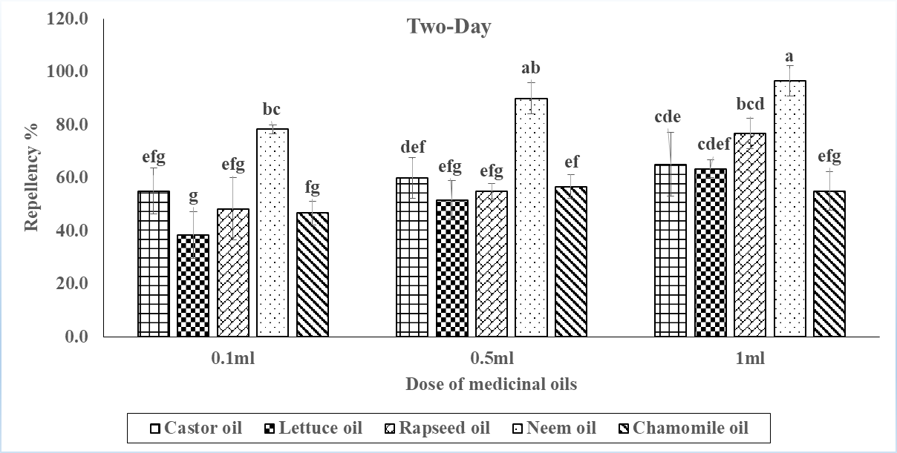
Fig. 3. Repellency percentage of different concentrations of medicinal oils against Tribolium castaneum after Two days
*Means followed by same letters are not significantly different (LSD = 18.13; P < 0.05)

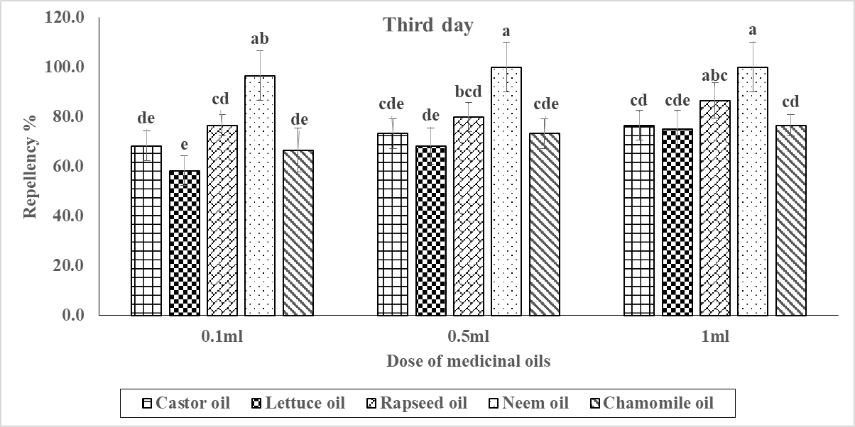
Fig. 4. Repellency percentage of different concentrations of medicinal oils against Tribolium castaneum after three days
*Means followed by same letters are not significantly different at the respective doses (LSD = 16.76; P < 0.05)

Fig. 5 showed the results regarding the overall repellent efficacy of various doses of medicinal oils at different time intervals i.e., one, two and three days against T. castaneum. At all the time intervals i.e., one day (F = 8.65, P = 0.001), two-days (F = 5.62, P = 0.0017) and three-days (F = 4.37, P = 0.0067), neem oil significantly showed the highest repellency percentage of 63.89±5.26, 88.33±3.33 and 98.89±1.11%, respectively. All other oils showed no significant difference among themselves to repel T. castaneum at different time intervals when applied at various doses. The results also indicated a rise in the repellency of T. castaneum with the increase in dose of various medicinal oils. Accordingly, a significant difference was recorded in various doses applied of medicinal oils after one-day (F = 3.36, P = 0.048), two-days (F = 5.89, P = 0.0069) and three-days (F = 4.38, P = 0.0214) hours of application. According to results, after one-day, overall repellency of T. castaneum recorded at 1.0 ml dose of all medicinal oils was 56.00±4.58%, followed by 0.5 ml (41.67±3.64%) and 0.1 (34.67±4.77%) ml doses. Similarly, after two- and three days of application, the highest repellency was recorded in 1.0 ml dose i.e., 71.33±4.24 and 83.00±3.34%, respectively, whereas the lowest repellency of T. castaneum was observed in 0.1-ml dose i.e., 53.33±4.70 and 73.33±4.16%, respectively. Moreover, the repellency percentage of beetles recorded at 0.5 ml dose after two- and three-days was 62.67±4.33 and 79.00±3.66%, respectively (Fig. 6).

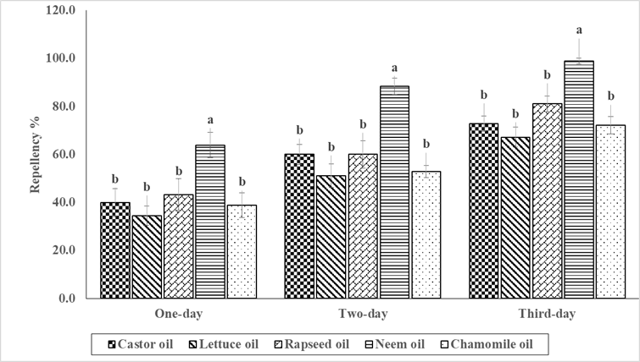
Fig. 5. Overall repellency percentage of various medicinal oils at different days intervals against Tribolium castaneum
*Means followed by same letters are not significantly different at their respective exposure time interval- LSD values @ P < 0.05
One-day = 14.171
Two-days = 1o.473
Three-days = 9.6807

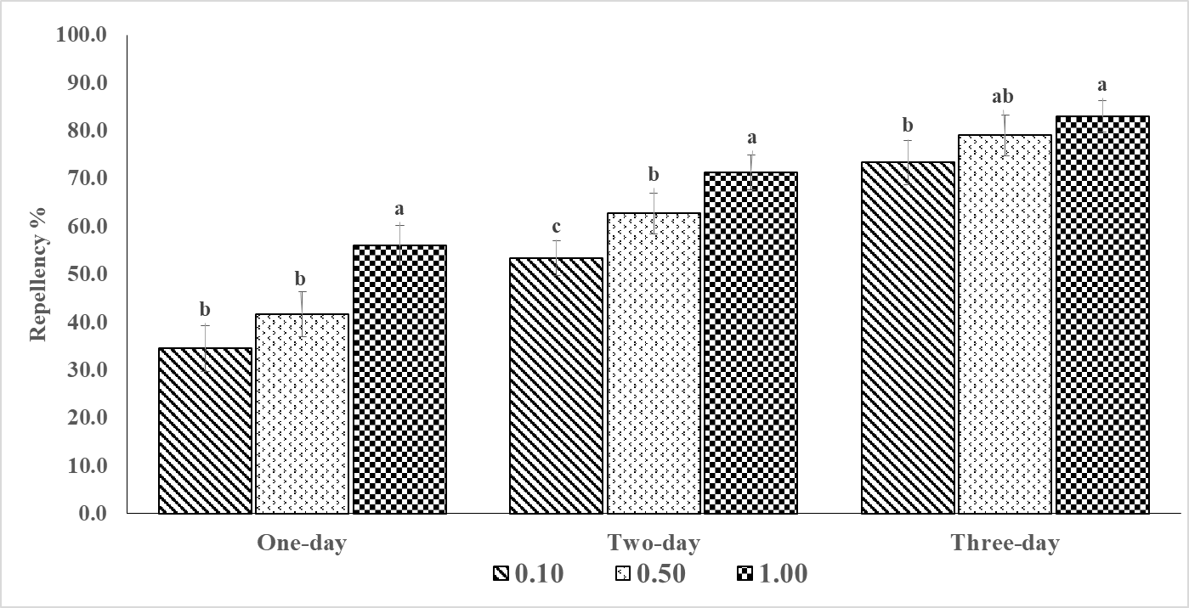
Fig. 6. Overall repellency percentage of different concentrations of medicinal oils at different days intervals against Tribolium castaneum
*Means followed by same letters are not significantly different at their respective exposure interval- LSD values @ P < 0.05; One-day = 10.977; Two-days = 8.1122; Three-days = 7.4986
Many plant extracts have also shown promising results on various biological parameters of T. castaneum with varying level of success. Generally, plants produced naturally occurring, volatile, complex secondary metabolites or compounds that possessed strong odor. Most of them are recognized for their bactericidal, fungicidal, virucidal, insecticidal and medicinal properties. Therefore, quest for the plant-based compounds to be use for the protection of stored products from damaging pests could lead to sustainable and healthy agriculture^{25,26}. Among plants, neem, A. indica is one of the widely studied plant as seed protectionist against many pests including more than 350 arthropod species, 12 nematode species, 15 fungi species, 3 viruses, and 2 snail species and one crustacean species^{27,28}. According to²⁹, extracts from various parts of neem has been successfully used for the management of storage, household and crop pests either used as fumigant or disinfectant in many countries of the world.
Among other plants, powders obtained from the rhizome of turmeric (Curcuma longa L.), and sweet flag (Acorus calamus L.) have elicited good results for lowering the population of T. castaneum³⁰. In another study,³¹ while screening forty Chinese local medicinal herbs found from thirty-two families for their bioactivity against T. castaneum and Sitophilus Zeamais L., mentioned that thirty of the herbs shown insecticidal properties against T. castaneum. Among the repellents tested against T. castaneum, powder of Annona squamosa L. has proven effective to protect the stored millet against T. castaneum when applied at the rate of 7.5g/25g (30% w/w).
Many plant based extracts and oils such as Peganum Hamala L.³², citrus essential oils³³, Tumha (Citrus colocynthis L.)³⁴, neem oil³⁵, Curcuma longa L. leaf oil, Lippia rugose L. (Lamiaceae), and Hyptis spicigera Lam. (Verbenaceae) ³⁶, essential oils extracted from the rhizomes of Zingiber zerumbet, Alpinia conchigera ,C. zedoaria ³⁷, Nicotiana tubacum and Salsola banyosma ³⁸ have shown insecticidal properties against T. castaneum with variable degree of success.
Thus, in continuation of the previous studies, all the medicinal oils used in the study i.e., neem, rapeseed, chamomile, castor, and lettuce showed promising repellent effects against T. castaneum and could be used as substances for stored grain protectants that are safe, nontoxic to humans, and eco‐friendly^{39,40}.
4. CONCLUSIONS
All the medicinal oils showed repellency potential against T. castaneum as neem was found most effective showing 100% repellency of T. castaneum at 0.5- and 1.0-ml dose after three days. A rise in the repellency of medicinal oils was recorded with the dose and exposure time. Among doses, although highest repellency was recorded at 1.0 ml, but not significantly different from 0.5 ml of the individual oils.
CONFLICT OF INTEREST
The authors declare no conflict of interest.

REFERENCES
- Hagstrum DW, Subramanyam B. Stored-product insect resource. AACC International. Inc., USA. 2009;518.
- Hagstrum D, Klejdysz T, Subramanyam B, Nawrot J. Atlas of stored-product insects and mites. AACC Press, St. Paul, MN, USA. 2013.
- Tiwari R, Sharma VK. Susceptibility of wheat germplasm to stored grain pests. Indian Journal of Entomology. 2002;64(1):1-11.
- Cui K, He L, Zhang Z, Zhang T, Mu W, Liu F. Evaluation of the efficacy of benzothiazole against the red flour beetle, Tribolium castaneum (Herbst). Pest Management Science. 2020;76:2726–2735.
- Singh BK, Singh SC, Singh VK. Observation on the biology of Tribolium castaneum (Herbst) (Coleoptera, Tenebrionidae) infesting wheat flour. Proceeding of Zoology Society India. 2016;5:49-52.
- Bossou AD, Ahoussi E, Ruysbergh E, Adams A, Smagghe G, Kimpe NDe, Mangelinckx S. Characterization of volatile compounds from three Cymbopogon species and Eucalyptus citriodora from Benin and their insecticidal activities against Tribolium castaneum. Industrial Crops and Products. 2015;76:306-317.
- Nayak MKMG, Falk RN, Emery PJ, Collins, Holloway JC. An analysis of trends, frequencies and factors influencing the development of resistance to phosphine in the red flour beetle Tribolium castaneum (Herbst) in Australia. J. of Stored Products Research. 2017;72:35-48.
- Huang Y, Li F., Liu M, Wang Y, Shen F, Tang P. Susceptibility of Tribolium castaneum to phosphine in China and functions of cytochrome P450s in phosphine resistance. Journal of Pest Sciences. 2019;92(3):1239-1248.
- Bai L, Jiao ML, Zang HY, Guo SS, Wang Y, Sang YL, Du SS. Chemical composition of essential oils from four Rhododendron species and their repellent activity against three stored-product insects. Environmental Science and Pollution Research. 2019;26(22):23198-23205.
- Buxton T, Takahashi S, Eddy Doh AM, Baffoe-Ansah J, Owusu EO, Kim C S. Insecticidal activities of cinnamic acid esters isolated from Ocimum gratissimum L. and Vitellaria paradoxa Gaertn leaves against Tribolium castaneum Hebst (Coleoptera: Tenebrionidae). Pest Management Science. 2020;76(1):257-267.
- Elansary HO, Salem MZ, Ashmawy NA, Yessoufou K, El-Settawy AA. In vitro antibacterial, antifungal and antioxidant activities of Eucalyptus spp. leaf extracts related to phenolic composition. Natural Product Research. 2017;31(24):2927-2930.
- Hussein HS, Salem MZ, Soliman AM. Repellent, attractive, and insecticidal effects of essential oils from Schinus terebinthifolius fruits and Corymbia citriodora leaves on two whitefly species, Bemisia tabaci, and Trialeurodes ricini. Scientia Horticulturae. 2017;216:111-119.
- Hamada HM, Awad M, El-Hefny M, Moustafa MAM. Insecticidal activity of garlic (Allium sativum) and ginger (Zingiber officinale) oils on the cotton leafworm, Spodoptera littoralis (Boisd.) (Lepidoptera: Noctuidae). African Entomology. 2018;26(1):84-94.
- Hamad YK, Abobakr Y, Salem MZ, Ali HM, Al-Sarar AS, Al-Zabib AA. Activity of plant extracts/essential oils against three plant pathogenic fungi and mosquito larvae: GC/MS analysis of bioactive compounds. BioResources. 2019;14(2):4489-4511.
- Wahba TF, Mackled MI, Selim S, El-Zemity SR. Toxicity and reproduction inhibitory effects of some monoterpenes against the cowpea weevil Callosobruchus maculatus F. (Coleoptera: Chrysomelidae: Bruchinae). Middle East Journal of Applied Sciences. 2018;8:1061-1070.
- Abdelsalam NR, Salem MZ, Ali HM, Mackled MI, Mervat EH, Elshikh MS, Hatamleh AA. Morphological, biochemical, molecular, and oil toxicity properties of Taxodium trees from different locations. Industrial Crops and Products. 2019;139: 111515. doi:10.3390/pr7110809.
- Feldlaufer MF, Ulrich KR. Essential oils as fumigants for bed bugs (Hemiptera: Cimicidae). Journal of Entomological Society. 2015; 50(2):129-137.
- Khiyari ME, Kasrati A, Jamali CA, Zeroual S, Markouk M, Bekkouche K, Wohlmuth H, Leach D, Abbad A. Chemical composition, antioxidant and insecticidal properties of essential oils from wild and cultivated Salvia aucheri subsp. blancoana (Webb. and Helder)), an endemic, threatened medicinal plant in Morocco. Industrial Crop and Products. 2014; 57:106–109.
- Nenaah GE. Chemical composition, toxicity and growth inhibitory activities of essential oils of three Achillea species and their nano-emulsions against Tribolium castaneum (Herbst). Industrial Crops and Products. 2014;53:252-260.
- Peixoto MG, Bacci L, Blank AF, Araújo APA, Alves PB, Silva JHS, Santos AA, Oliveira AP, da Costa AS and de Fátima Arrigoni-Blank M. Toxicity and repellency of essential oils of Lippia alba chemotypes and their major monoterpenes against stored grain insects. Industrial Crops and Products. 2015;71:31-36.
- Senthil-Nathan S. Physiological and biochemical effect of neem and other Meliaceae plants secondary metabolites against Lepidopteran insects. Frontiers in Physiology. 2013;l4. doi.org/10.3389/fphys.2013.00359.
- Park MA, Chang Y, Choi I, Bai J, Ja-Hayun N, Han J. Development of a comprehensive biological hazard-proof packaging film with insect repellent, antibacterial and antifungal activities. Journal of Food Science. 2018; 28:181-189.
- Lee HE, Hong SJ, Hassan N, Baek EJ, Kim JT, Kim YD and Park MK. Repellent efficacy of essential oils and plant extracts against Tribolium castaneum and Plodia interpunctella. Entomological Research. 2020;50:450-459.
- Jo HJ, Park KM, Min SC, Na JH, Park KH, Han J. Development of an anti-insect sachet using a plyvinyl alcohol- cinnamon oil polymer strip against Plodia interpunctella. Journal of Food Science. 2013;78:1713-1720.
- Silva GN, Faroni LRA, Sousa AH, Freitas RS. Bioactivity of Jatropha curcas L. to insect pests of stored products. Journal of Stored Products Research. 2012;48:111-113.
- Singh B, Kaur A. Control of insect pests in crop plants and stored food grains using plant saponins: a review. LWT- Food Science and Technology. 2018;87:93-101.
- Ogbuewu IP, OdoemenamVU, Obikaonu HO, Opara MN, Emenalom OO, Uchegbu MC, Okoli IC, Esonu BO, Iloeje MU. The growing importance of neem (Azadirachta indica A. Juss) in agriculture, industry, medicine and environment: A review. Research Journal of Medicinal Plants. 2011;5(3):230-245.
- Uddin MS, Nuri ZN, Khorshed M. Neem (Azadirachta indica) in health care: A review. International Journal of Unani and Integrative Medicine. 2018;2(2):81-87.
- Jagannathan R, Ramesh RV, Kalyanakumar V. A review on neem derivatives and their agricultural applications. International Journal of Pharmacy and Technology. 2015;6(3):3010- 3016.
- Iqbal J, Jilani G, Aslam M. Growth inhibiting effects of three different plant extracts on Tribolium castaneum (Herbst) (Tenebrionidae: Coleoptera). Journal of Bioresource Management. 2015;2(2):40-48.
- Liu ZL, Goh SH, Ho SH. Screening of Chinese medicinal herbs for bioactivity against Sitophilus zeamais Motschulsky and Tribolium castaneum (Herbst). Journal of Stored Products Research. 2007;43(3):290-296.
- Jbilou R, Ennabili A, Sayah F. Insecticidal activity of four medicinal plant extracts against Tribolium castaneum (Herbst) (Coleoptera: Tenebrionidae). African Journal of Biotechnology. 2006;5(10):936-940.
- Bilal H, Akram W, Hassan SA, Zia A, Bhatti AR, Mastoi MI, Aslam S. Insecticidal and repellent potential of citrus essential oils against Tribolium castaneum Herbst (Coleoptera: Tenebriomidae). Pakistan Journal of Zoology. 2015;47(4):997-1002.
- Nadeem M, Iqbal J, Khattak MK, Shahzad M. Management of Tribolium castaneum (Hbst.) (Coleoptera: Tenebrionidae) using neem (Azadirachta indica A. Juss) and tumha (Citrullus colocynthis) (L.). Pakistan Journal of Zoology. 2012;44(5):1325-1331.
- Rahila N. Studies on Neem (Azadirachta indica A. Juss) derivatives as protectants against stored grain insects. Ph.D. thesis, University of Karachi, Karachi, Pakistan. 2006.
- Kouninki H, Hance T, Noudjou FA, Lognay G, Malaisse F, Ngassoum MB, Mapongmetsem PM, Ngamo LS, Haubruge E. Toxicity of some terpenoids of essential oils of Xylopia aethiopica from Cameroon against Sitophilus zeamais Motschulsky. Journal of Applied Entomology. 2007;131(4):269-274.
- Suthisut D, Fields PG, Chandrapatya A. Fumigant toxicity of essential oils from three Thai plants (Zingiberaceae) and their major compounds against Sitophilus zeamais, Tribolium castaneum and two parasitoids. Journal of Stored Products Research. 2011;47(3):222-230.
- Sagheer M, Zia S, Razaq A, Mahboob A, Mehmood K, Haider Z. Comparative bioefficacy of different citrus peel extracts as grain protectant against Callosobruchus chinensis, Trogoderma granarium and Tribolium castaneum. World Applied Science Journal. 2013;21(12): 1760-9.
- Batish DR, Singh HP, Kohli RK, Kaur S. Eucalyptus essential oil as a natural pesticide. Journal of Forest Ecology and Management. 2008;256:2166–2174.
- Wang J, Zhu F, Zhou XM, Niu CY, Lei CL. Repellent and fumigant activity of essential oil from Artemisia vulgaris to Tribolium castaneum (Herbst) (Coleoptera: Tenebrionidae). Journal of Stored Products Research. 2006 42:339–347.

This work is licensed under a Creative Commons Attribution-Non Commercial 4.0 International License. To read the copy of this license please visit: https://creativecommons.org/licenses/by-nc/4.0/



